**Buffers and Reagents:**

ATAC- RSB (Resuspension buffer): Filter and Store at 4oC.

|  |  |  |
| --- | --- | --- |
| Reagent | Final Concentration | Volume for 50ml |
| 1M Tris-HCL pH 7.4 | 10 mM | 500 ul |
| 5M NaCl | 10 mM | 100 ul |
| 1M MgCl2 | 3 mM | 150 ul |
| Nuclease-free water | NA | 49.25 ml |

Digitonin: Promega, cat# G9441- Digitonin is supplied at 2% in DMSO. Dilute 1:1 with water to make a 1% (100x) stock solution. Store in small aliquots to avoid more than 5 freeze thaw cycles. Can be kept at -20oC for up to 6 months.

Tween-20: Sigma/Roche cat# 11332465001, Tween-20 is supplied at 10%. Use at this concentration (100x stock). Store at 4oC. (If using a 100% Tween-20, from any other source make sure to prepare a 10% stock solution for use.)

NP40/ IGEPAL CA-630: NP40 from Sigma/Roche cat# 11332473001 is recommended in Corces et al paper, but is not sold anymore. We use IGEPAL CA-630 from Sigma, cat# I8896, as substitute. Prepare a 10% solution in water. Use at this concentration (100x stock). Store at 4oC.

SYBR Green I Nucleic Acid Gel Stain - Life Technologies cat# S7563, SYBR Green I is supplied at 10,000X concentrate in DMSO. Dilute 1:100 with 10 mM Tris-Cl, pH 7.4 to make a 100x stock. Store at -20oC.

Illumina Tagment DNA TDE1 Enzyme and Buffer: Small Kit, cat# 20034197 (0.17 ml Enzyme) **OR**

Illumina Tagment DNA TDE1 Enzyme and Buffer: Large Kit, cat# 20034198 (0.65 ml Enzyme)

MinElute PCR Purification Kit: Qiagen, cat# 28006

NEBNext High-Fidelity 2X PCR Master Mix: NEB, cat# M0541S

Agencourt AMPure XP magnetic beads: Beckman Coulter, cat # A63880

Qubit dsDNA HS Assay Kit & fluorometer: Life Technologies, cat # Q32851

Agilent High Sensitivity DNA Kit: Agilent, cat# 5067-4626

Nuclease-Free water: Ambion, cat# AM9937

1XPBS

Primers (attached at the end)

80% Ethanol (freshly prepared)

- This protocol is primarily based on Corces et al, Nat Methods, 2017 paper with the following modification:

- Instead of NP40 we have been using IGEPAL CA-630 as a substitute, as NP40 (Sigma/Roche cat# 11332473001) is no longer sold by the company.

- We found that column purification of the libraries does not remove primer-dimers (78 bp), and our libraries often contained large fragments 1,000-10,000 bp in length. Therefore, we use magnetic bead purification to remove primer-dimers (78 bp). A double-sided bead purification is usually not required as the large fragments (1,000-10,000 bp) do not interfere with the sequencing.

- We typically use 35,000-50,000 viable cells for best results. We have found as few as 10,000 viable cells to work as well. If cells are not FACS enriched for viable cells, count cells using cell counter. For samples with viability less than 90% use Miltenyi Biotec, dead cell removal kit.

- Caution: Cells must be fresh and viable. For frozen cells see the **Frozen-tissues ATAC-seq protocol**.

**Cell Lysis**

1. Pellet 50,000 viable cells at 500 RCF at 4°C for 5 min in a fixed angle centrifuge. (Cell pellet should be visible).
2. Aspirate all supernatant, carefully avoiding visible cell pellet, using two pipetting steps (aspirate down to 100 ul with a p1000 pipette and remove final 100 ul with a p200  pipette).
3. Add 50 ul cold ATAC-Resuspension Buffer (RSB) containing 0.1% IGEPAL, 0.1% Tween-20, and 0.01% Digitonin and pipette up and down 3 times.
4. Incubate on ice for 3 minutes.
5. Wash out lysis with 1 ml of cold ATAC-RSB containing 0.1% Tween-20 but NO IGEPAL or digitonin and invert tube 3 times to mix
6. Pellet nuclei at 500 RCF for 10 min at 4°C in a fixed angle centrifuge. (while cells are centrifuging prepare the transposition mix)
7. Aspirate all supernatant, carefully avoiding visible nuclei pellet, using two pipetting steps

(aspirate down to 100 ul with a p1000 pipette and remove final 100 ul with a p200 pipette).

**Transposition**

1. Resuspend cell pellet in 50 ul of transposition mixture by pipetting up and down 6 times.  **Transposition mix per sample**

25 μl 2x TD buffer,

2.5 μl Transposase (100nM final)

16.5 μl PBS,

0.5 μl 1% digitonin

0.5 μl 10% Tween-20

5 μl Nuclease-Free water

50 μl

1. Incubate reaction at 37°C for 30 minutes in a thermomixer with 1000 RPM mixing.

**DNA Purification**

10. Cleanup reaction using Qiagen MinElute PCR Purification Kit. (If you don’t have time the ATAC reaction can be stored at -20oC after resuspension in 250 ul (5 volumes) of PB buffer. The DNA is stable for 2 weeks in this buffer at -20oC. Thaw and mix thoroughly before loading onto the column).

11. Elute DNA in 21 μl EB (Elution Buffer) and store at -20oC until ready to amplify. This elution typically results in ~20 μl of product.

**Pre-Amplification of transposed fragments (Library Generation)**

12. PCR reaction per sample:

20 μl Transposed sample

2.5 μl Ad1_noMX universal primer (25μM)

2.5 μl Ad2.* indexing primer (25μM)

25 μl NEBNext High-Fidelity 2X PCR Master Mix

50 μl

13. Cycling Conditions: 72oC 5 min

**]**

98oC 30 sec

98oC 10 sec

63oC 30 sec x5 cycle Pre-Amplification

72 oC 1 min

14. Remove tubes from thermocycler and store on ice. To determine additional cycles required proceed to qPCR amplification using 5 μl of pre-amplified sample.

**qPCR amplification to determine additional cycles:**

15. qPCR reaction per sample:

5 μl Pre-Amplified sample

4.41 μl Nuclease-Free water

0.25 μl Ad1_noMX universal primer (25μM)

0.25 μl Ad2.* indexing primer (25μM)

0.09 μl 100x SYBR Green I

5 μl NEBNext High-Fidelity 2X PCR Master Mix

15 μl

16. Cycling Conditions for qPCR:

**]**

98oC 30 sec

98oC 10 sec

63oC 30 sec x20 cycles

72 oC 1 min

17. Plot linear Relative fluorescence (Rn) vs Cycle number: The cycle number (N) that corresponds to 1/3rd of the maximum fluorescence intensity (Rn), is the number of additional PCR cycles required for library amplification. (Note: Using Omni-ATAC protocol we find that the number of cycles required is very low. Certain libraries show sufficient amplification after 5 pre-amplification cycles and may not need additional PCR cycles).

**Final Amplification:**

18. Run the remaining 45 μl of Pre-Amplifiled library to the appropriate cycle number (N) determined by qPCR.

**]**

98oC 30 sec

98oC 10 sec

63oC 30 sec xN cycles

72 oC 1 min

**Library Purification:**

**- For single left-sided bead purification (to remove primer dimers):**

- Transfer each PCR sample to an epi tube, add 1.6X volume (72 μl) AMPure XP beads, pipet up and down 10x to mix thoroughly. (Note: The original protocol recommends 1.8:1 ratio, however results from Keats lab suggest that the 1.6:1 ratio has slightly more purified DNA than the recommended 1.8:1 ratio. For details refer to link:<https://www.keatslab.org/blog/pcrpurificationampureandsimple)>

- Incubate at room temperature for 10 minutes.

- Place epi tubes in magnetic rack for 5 minutes.

- Discard supernatant.

- Wash beads with 200 μl 80% EtOH (freshly made), pipet EtOH over beads 10x, then discard EtOH.

- Leave tube on magnetic rack with cap open for 10 minutes.

- Ensure all EtOH is removed.

- Resuspend beads in 20 μl nuclease-free H2O, pipet up and down 10x to mix thoroughly.

- Place epi tube in magnetic rack for 1-5 minutes.

- Transfer supernatant to new epi tube.

**- For double-sided bead purification (to remove primer dimers and large >1,000 bp fragments):** (we have found that the presence of the large fragments (1,000-10,000 bp) does not interfere with the sequencing and therefore removal of large fragments is not critical)

- Transfer each PCR sample to an epi tube, add 0.5X volume (22.5 μl) AMPure XP beads, pipet up and down 10x to mix thoroughly.

- Incubate at room temperature for 10 minutes.

- Place epi tubes in magnetic rack for 5 minutes.

- Transfer supernatant to new epi tube.

- Add 1.1X original volume (49.5 μl) AMPure XP beads, pipet up and down 10x to mix thoroughly. (This results in a final 1.6X bead buffer:sample ratio.)

- Incubate at room temperature for 10 minutes.

- Place epi tubes in magnetic rack for 5 minutes.

- Discard supernatant.

- Wash beads with 200 μl 80% EtOH (freshly made), pipet EtOH over beads 10x, then discard EtOH.

- Leave tube on magnetic rack with cap open for 10 minutes.

- Ensure all EtOH is removed.

- Resuspend beads in 20 μl nuclease-free H2O, pipet up and down 10x to mix thoroughly.

- Place epi tube in magnetic rack for 1-5 minutes.

- Transfer supernatant to new epi tube.

- Store purified libraries at -20oC.

**Assessing Library Quality:**

- Use 1 μl of each library to measure DNA concentration by QuBit.

- Dilute each library to 1ng/ul in nuclease-free H2O.

- Run 1 μl of each diluted library on an Agilent High Sensitivity DNA Bioanalysis chip.

**Sequencing:**

- If sending to Novogene do 150 bp paired-end (150PE) sequencing.

- Goal is to obtain >45-50 million reads per sample minimum.

- All the treated and control samples must be sequenced at the same depth to assess open vs closed chromatin regions.

**Table of PCR Primers (based on TruSeq indices):**

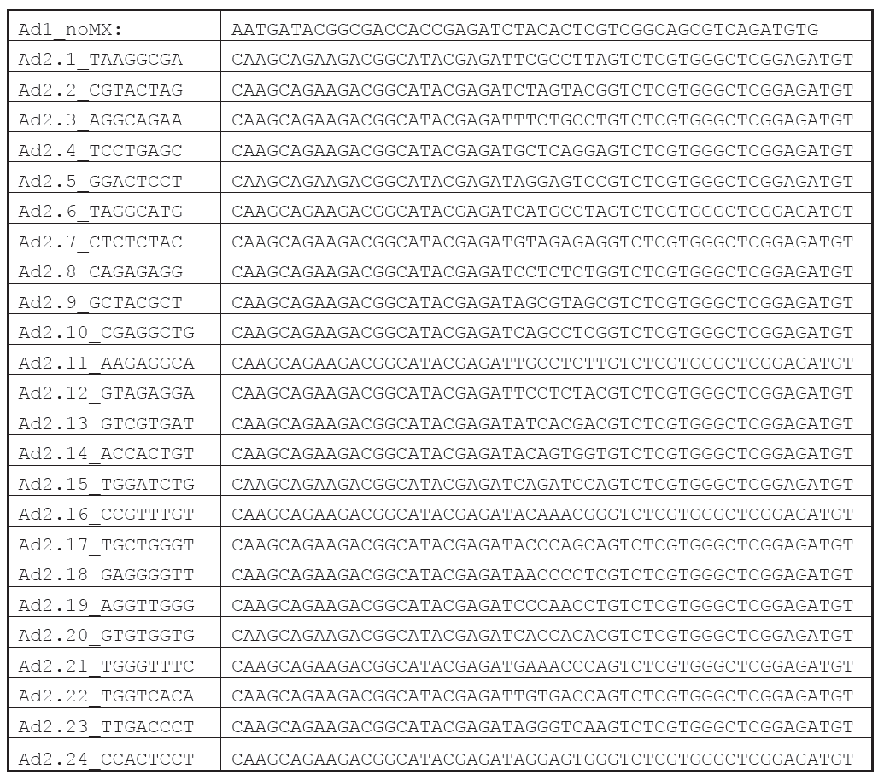

**References:**

[1] Buenrostro JD, Giresi PG, Zaba LC, Chang HY, Greenleaf WJ (2013) Transposition of native chromatin for fast and sensitive epigenomic profiling of open chromatin, DNA-binding proteins and nucleosome position. Nature methods 10: 1213-1218

[2] Buenrostro JD, Wu B, Chang HY, Greenleaf WJ (2015) ATAC-seq: A Method for Assaying Chromatin Accessibility Genome-Wide. Current protocols in molecular biology / edited by Frederick M Ausubel [et al] 109: 21.29.21-21.29.29

[3] Corces et al. (2017) An improved atac-seq protocol reduces background and enables interrogation of frozen tissues. Nature Methods, 2017.